Defne Yaz Kılıç

Section 003

22102167

07.11.2023

**EEE 313- Electronic Circuit Design**

*-Lab 03-*

*Introduction*

The purpose of this lab was to design a nMOS common source amplifier firstly by setting up two test circuits for finding the threshold voltage (Vth), the Kn and λ values and the IDS - VDS relationship of the transistor. The second part consists of setting up the amplifier circuit by finding the values of the unknown resistances and capacitor, gm and ro values. At the end, what is expected is to show input and output voltages on the same oscilloscope screen in order to see the amplification effect.

*Theory*

1. **Test Circuit for finding Vth**

The circuit design is as follows:

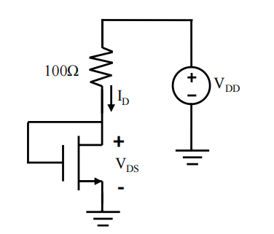

*Fig.1 Test Circuit for finding Vth*

After setting up the circuit in Fig.1, VDD is increased until ID became 30 mA. The ID current is measured using a multimeter connected in series to the 100Ω resistor. The transistor is assumed as ON when ID=1mA. In order to find the threshold voltage we need to find the VGS value due to the condition given by (1). For this test circuit since VGS = VDS we can use the same relation (1) for VDS as well. VDS can be found by doing KVL which gives the equation (2).

ON state condition: VGS > VTH (1)

VDS = VDD - ID *100Ω (2)

Since the transistor is assumed ON when ID=1mA, when the ID value read on the multimeter becomes 1 mA, the corresponding VDS  voltage is hence equal to the VTH. The results are as follows:

* VDD = 2.13 V when ID=1mA
* VTH = 2.13- 100*10-3 = 2.03V

For the plotting part, VDD value is increased until ID becomes 30 mA and the corresponding ID versus VDS  curve is obtained:

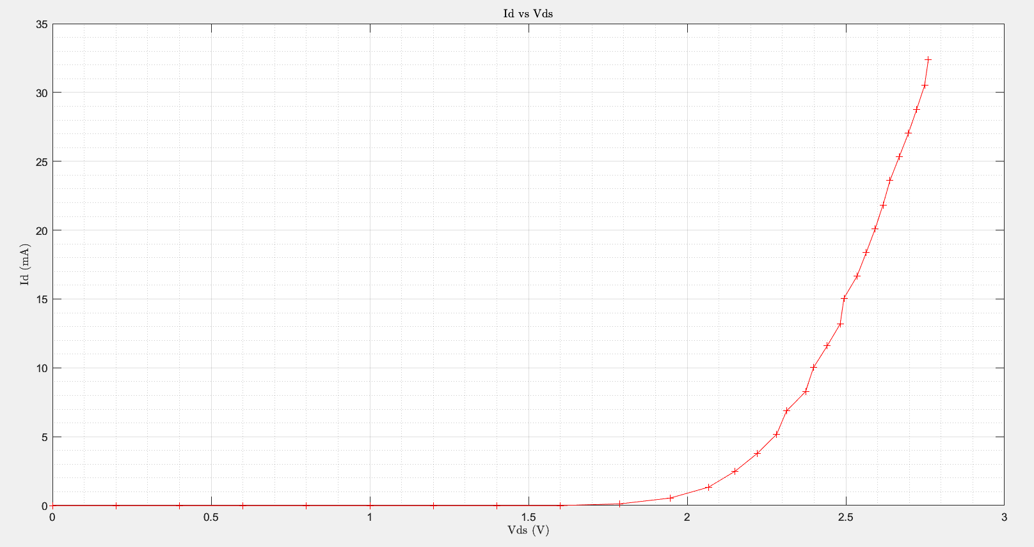

*Fig.2. ID-VDS  curve for part 1 test circuit*

This biasing circuit, due to the equality between VGS and VDS, allows us to find the threshold voltage by changing the VDD.

1. **Test Circuit to Plot ID-VDS Curves**

For this part the following circuit design is used:

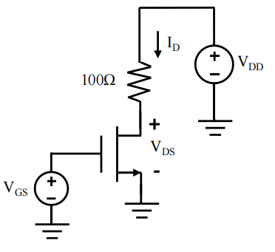

*Fig.3. Test Circuit to Plot ID-VDS Curves*

The VGS value is sweep fixed and the VDD value is slowly changed while recording the ID. 3 ID versus VDS curves are plotted for different VGS values. For finding the VDS, same relation (2) stated in part 1. is used. The corresponding plots can be seen below.

* When VGS = VTH + 0.3V= 2.33V:

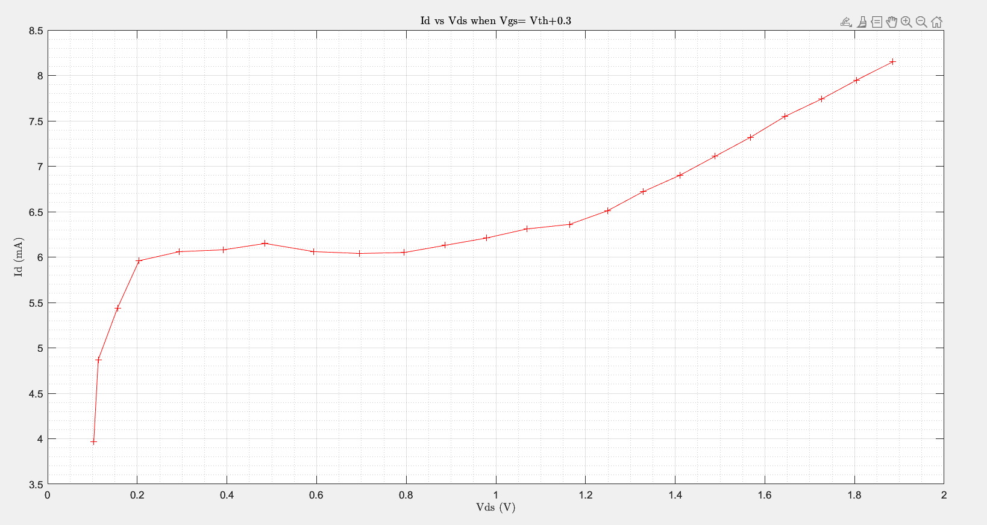

*Fig.4. Plot of ID-VDS when VGS=2.33V*

* When VGS = VTH + 0.4V= 2.43V:

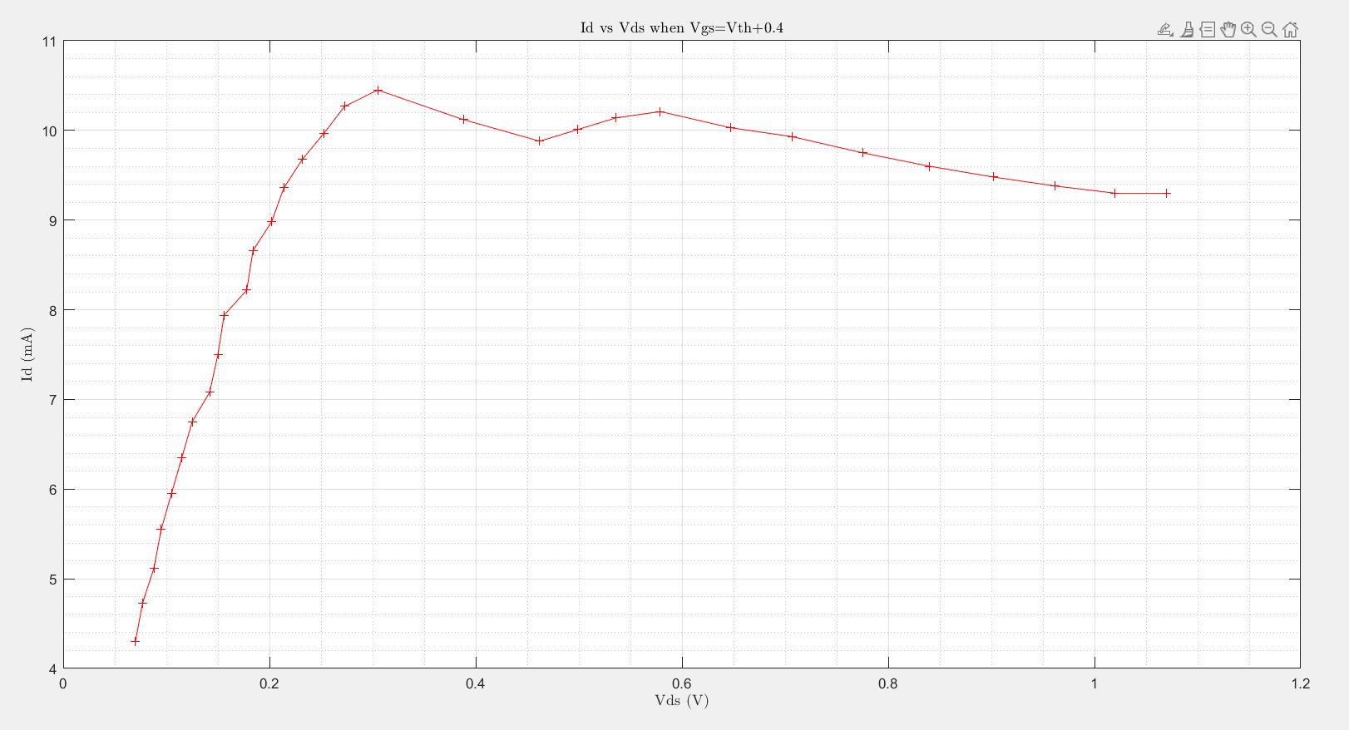

*Fig.5. Plot of ID-VDS when VGS=2.43V*

* When VGS = VTH + 0.5V=2.53V:

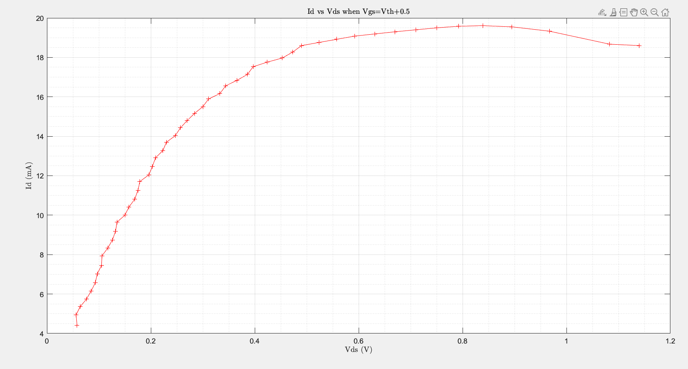

*Fig.6. Plot of ID-VDS when VGS=2.53V*

In the ideal case, when the transistor is operating in the SAT region the drain current *ID* is independent from VDS value hence after saturation even though the drain voltage increases, the drain to source current becomes stabilized creating a ID-VDS curve with slope equal to zero. However in real life conditions there exist a nonzero slope, hence the increase in the drain voltage effects the drain to source current. This event decreases the effective channel length and causes the phenomenon called channel length modulation [1]. For a non-ideal n-channel device, the ID versus VDS characteristics in SAT region with nonzero slope is given in eq.(3).



 (3)

Where

-Kn is the transconduction or simply conduction parameter which is a device specific function of both the electrical (oxide permittivity and thickness, mobility of the electrons) and geometric (width and length) parameters[1].

-λ is a positive parameter called the length modulation parameter.

The effect of channel length modulation produce a finite output resistance named r0. The plot for ID versus VDS curve for different VGS values is shown in Fig.6.

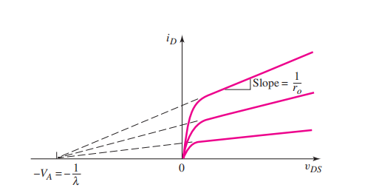

VGS3

* VGS1<VGS2<VGS3

VGS2

VGS1

*Fig.7. The effect of channel length modulation on ID-VDS relationship*

From Fig.7. we can see that the Q point shifts towards left and up meaning that the corresponding ID value increases for larger values of VGS. When we compare the experimental plots in Figs. 4,5,6. it can be seen that for a specific VDS value the corresponding drain current is smallest when VGS =2.33V and largest when VGS =2.53V which is consistent with the theory.

For Kn and λ calculations the plot in Fig.6 is used when VGS =2.53V. Two value from the SAT region is taken as shown in Fig.8. Expressing the chosen values as (VDS1,ID1),(VDS2,ID2) and placing them in eq.3. with VGS-VTH=0.5 we get:

 (4)

 (5)

Taking the ratio, λ is found as:

 (6)

Placing the chosen values into their places λ is calculated as 0.039 V-1. Placing λ in one of the equations Kn  is then calculated as 75.98 mA/V2.

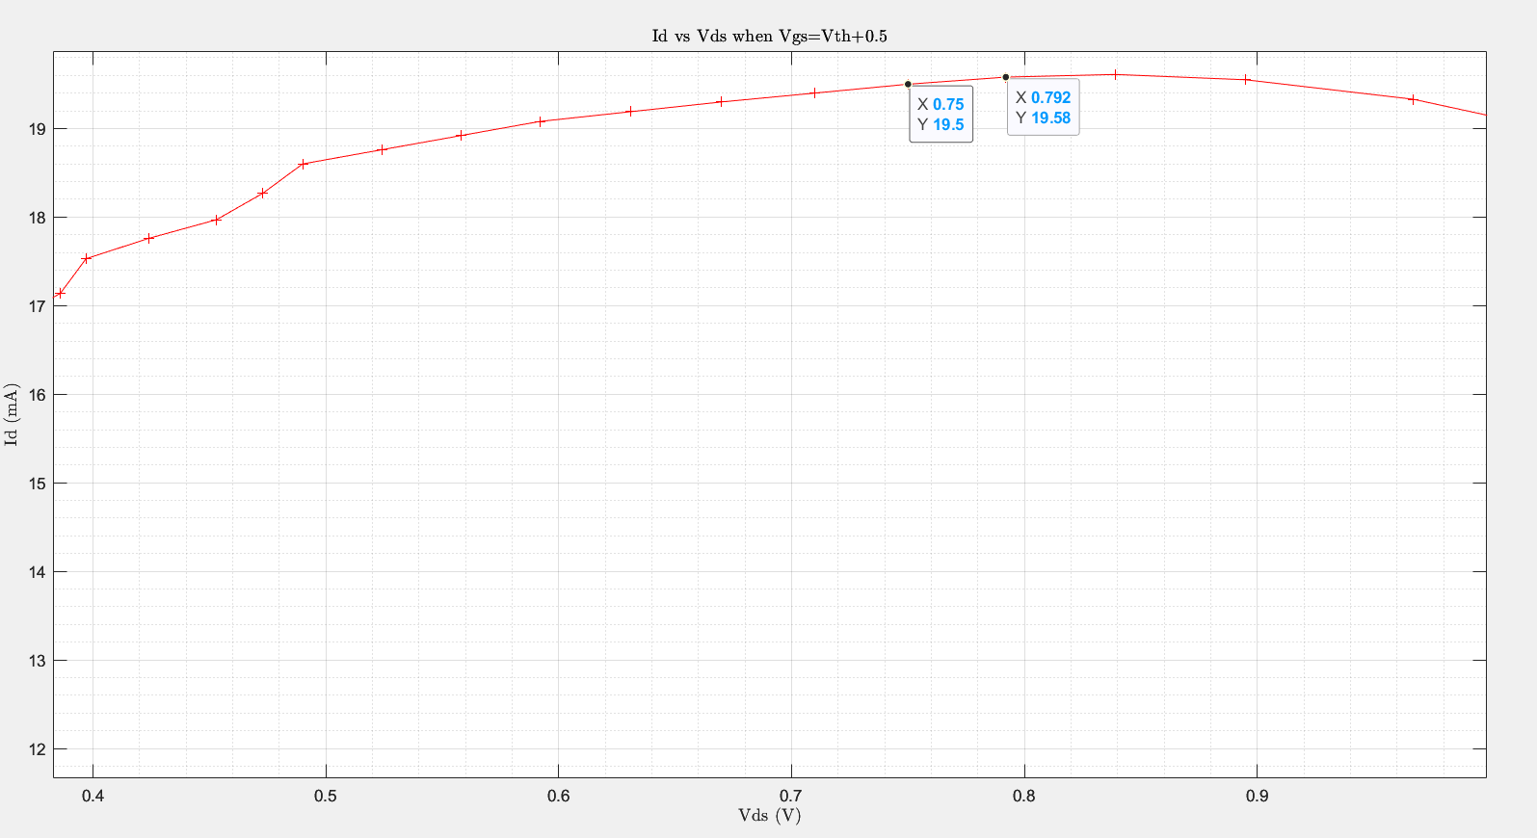

*Fig.8. Values chosen for Kn & λ calculations*

1. **Common Source Amplifier**

The common source amplifier design for this part is shown in Fig.9.

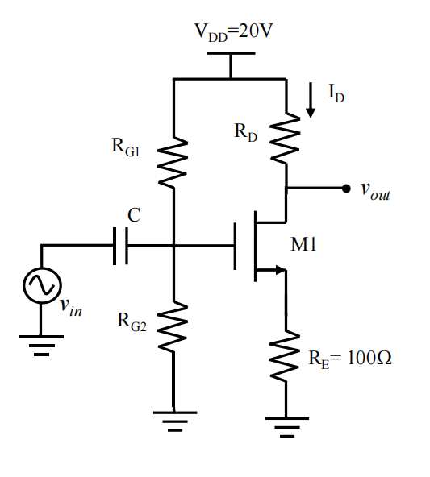

*Fig.9. Common source amplifier design*

The circuit specifications are as follows.

* Rin >30 K
* Rout < 2K
* 10 mA < ID< 15 mA
* |Av|> 9 when Vin = 0.1sin(10KHz*t)

Ro and Gm Calculations

Moving to the gm and ro calculations, from eq (3) we know that:

 (7)

From (7) ro is calculated as

 (8)

The small signal amplifier circuit consists of DC and AC gate to source currents. By internalization we can separate the two and apply superposition. Hence the total instantaneous current (iD) has two components: quiescent drain current IDQ & small signal current id

 (9)

The small signal AC current is given by

 (10)

From (9) the transconductance parameter gm is found as

(11)

Resistor, Capacitor & Gain Calculations

Continuing with the resistor and capacitor calculations firstly the small signal model of the circuit should be drawn (Fig.10).

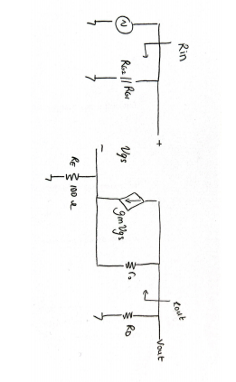

1

*Fig.10. Small Signal model of the circuit*

 (12)

Using the conditions in (12) RG1 and RG2 are chosen as 330K and 39K respectively. However the gain with these values was lower than 9 hence RG1 is replaced with 180K. The reason for this is explained later in this report.

For RD, firstly Rout1 is needed to be calculated, hence the analysis in Fig.11 is made. Using (12) calculated Rout1 and Rout are used for choosing an RD within the given specifications. For the choosing process a more experimental path is followed. I started with 1.2K and increased RD up to 1.8K for the correct gain.

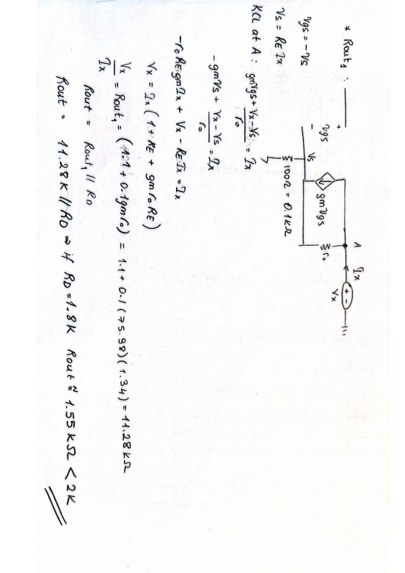

*Fig.11. RD, Rout1,Rout calculations*

For all the resistor values, after finding a convenient interval meeting the lab conditions, the values are changed by trial and error for achieving a gain larger than 9. How to change the values depends on how each component effects the gain. Hence the following calculations are made.

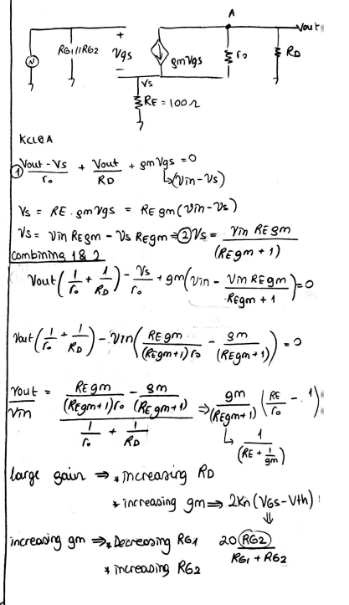

*Fig.12. Gain Calculation*

Therefore considering the gain relationship and experimental results the resistor values are chosen as:

* RG1 = 180K
* RG2 = 39K
* RD= 1.8K

For the capacitance value, the magnitude of the capacitor impedance (eq.13) should be less than the thevenin resistance between the capacitor terminals in order to have a short circuit [1].

 (13)

For small impedance the capacitance value should be large. If it is chosen as 100μF, this condition is satisfied. The 100μF is found by trial and error in the experimental part. The coupling capacitor here helps to separate the DC and Ac voltages by acting as a short circuit for AC and open circuit for DC.

Saturation Check

In order to make sure that the chosen value satisfy the saturation the following calculations are made. If the drain current is 10 mA, the transistor is in the Sat region with the chosen values.

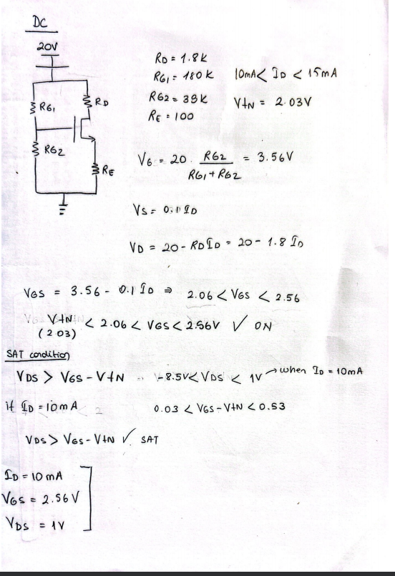

*Fig.13. Saturation Check*

*Hardware Implementation*

Gain

Fig.14 shows the common source amplifier circuit.

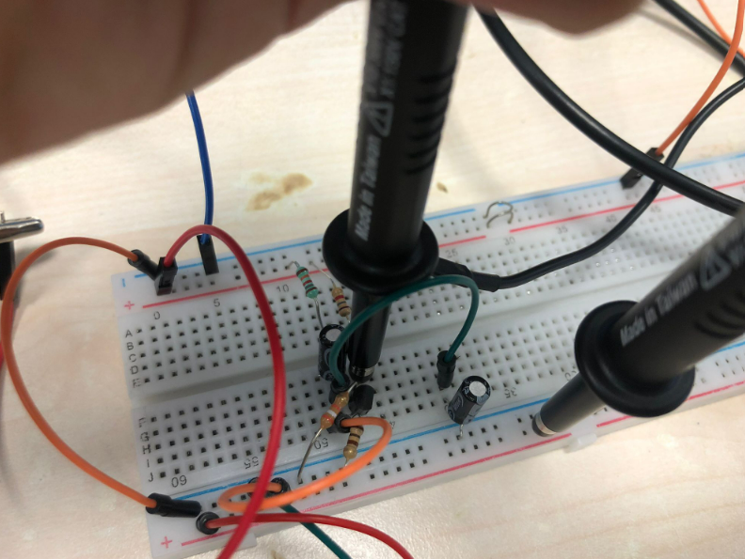

*Fig.14. Common Source Amplifier*

The input and output voltages are measured at the same time for seeing the amplification effect. Normally due to the internal resistance of the source generator, instead of 100mVppsin(10KHz*t), 50mVppsin(10KHz*t) should be applied for seeing the 100MVpp at the load resistance. However the pictures that I have taken shows the results for 100mVppsin(10KHz*t) applied input which results in 200mVpp. This is an error that I have made and I didn’t had time to retake the pictures. Nevertheless, the gain is still the same hence for the gain measurement they are still valid.

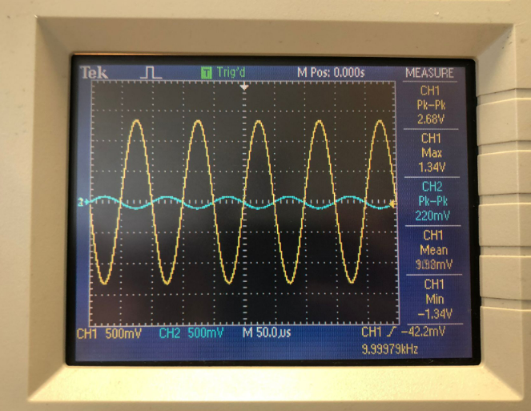

*Fig.15. Input (Blue) & Output (Yellow) signals*

As can be seen from fig.15. the gain of the amplifier Av = = .

Moving to the distortion effect, if the input signal is increased up to a point where the sinusoidal fluctuations pass beyond the linear region, that is the saturation limits, distortion starts to occur. And the output waves seem like cut off sine waves. When the input Vpp is increased up to 0.5 V resulting 1V read on the load seen from the signal generator, that is to say when 1Vppsin(10KHz*t) is applied, the distortion started to occur as seen in Fig.16.

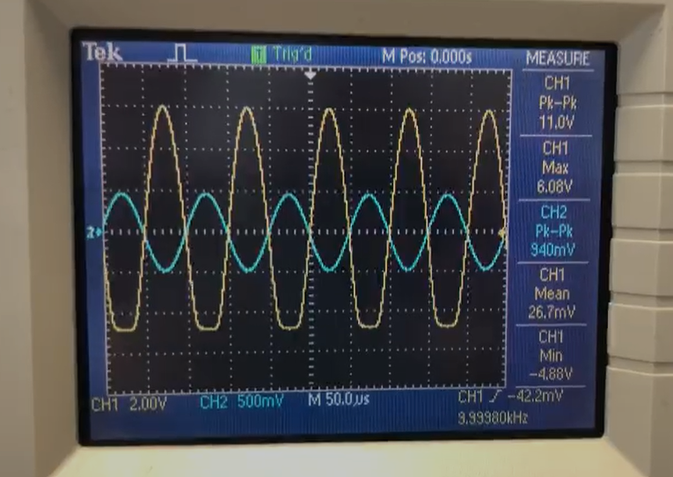

*Fig.16. Distorted Output Signal*

Adding a Capacitor Parallel to RE

Since the capacitor acts as short circuit for AC inputs, the gate resistance becomes shorted with the added capacitor as shown in Fig.17.

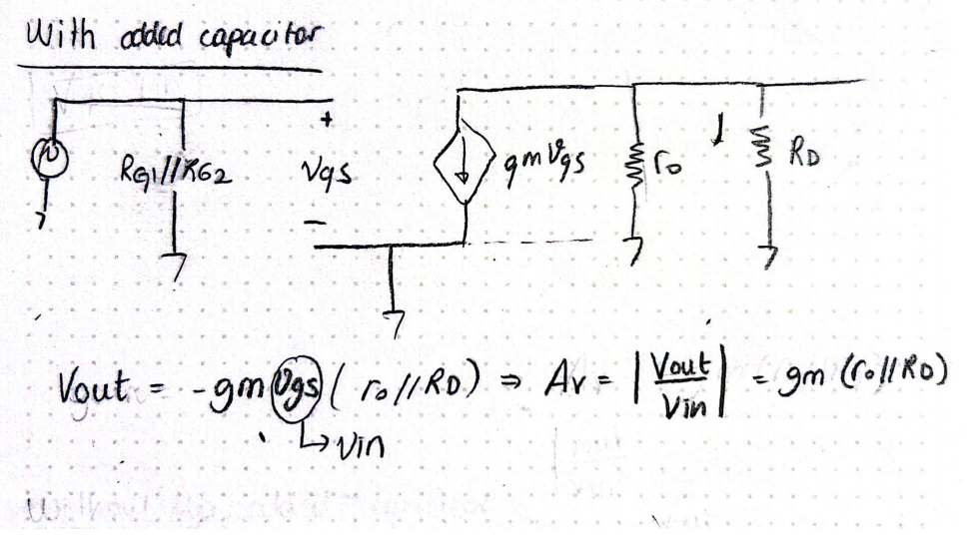

*Fig.17. Gain with the added capacitor*

From the calculated gm, ro and RD values the gain can be calculated as

Av = = 58.36

Which is way more larger than with the RE case. Fig.18. shows the real life implementation results of the capacitor.

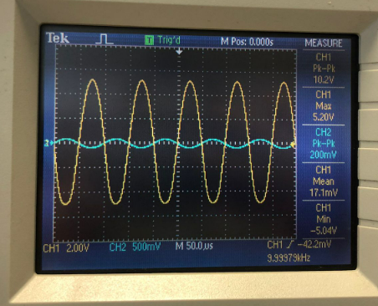

*Fig.18. Input (Blue) & Output (Yellow) signals without RE*

The experimental gain is: Av = = which is even if lower than the expected value enough to show the increase in the gain with the added capacitor.

**Conclusion**

This lab was very useful for understanding the DC and AC analysis of MOSFET amplifiers. The first two parts was for understanding the general characteristics of the transistor such as threshold voltage, ID-VDS characteristics, Kn,λ, gm and ro values. The most challenging part was definitely the ID-VDS plots. It took so long to get the correct data points and even though I tried to obtain plots close to ideal case some plots did not turn out as nice as expected. Due to the variations in plots calculations of Kn,λ was also hard as well. Choosing the suitable two points was crucial for this part. Depending on the chosen points the results were changing a lot. For the amplifier part, I learned how to decide on the values of different parameters without surpassing the required specifications. The analysis of the circuit helped me a lot while deciding on the resistor values. Being able to see how each component effects the gain is an important skill to have. Maintaining the SAT state was also important, I saw that even though in the small signal analysis the DC part is kept ignored you also have to think about the changes in the DC analysis as well. The distortion was one of the examples, it seems like the input voltage can be increased as much as wanted in the AC analysis however I saw that this is not the case. Lastly the added capacitor showed that the gain can be increased drastically however since in that case gm directly affects the gain, changes in the current can indirectly modify the gain. Which is not a desired case considering the stability of the amplifier.

**References**

1. D. Neaman, *Microelectronics Circuit Analysis and Design*. McGraw-Hill Science Engineering, 2007.

**Appendix**

Vth calculation

Vdd= [0:0.2:6];

Ids=[0 0 0 0 0 0 0 0 0 0.12 0.54 1.33 2.49 3.79 5.18 6.87 8.27 10.02 11.59 13.18 15.06 16.65 18.36 20.08 21.83 23.61 25.32 27.03 28.77 30.52 32.40];

Vds= Vdd- 0.1*Ids

figure

plot (Vds,Ids,'r-+');

ylabel ({'Id (mA)'},'Interpreter','latex');

xlabel ({'Vds (V)'},'Interpreter','latex');

box on

grid, grid minor

title({'Id vs Vds'},'Interpreter','latex')

%Vth

Vth=2.13- 100*(10^-3) % 2.03V

ID-VDS plots for different VGS values

%Part 2

%1) Vgs=2.33V:

Vdd= [0.5:0.1:2.7]

Id=[3.97 4.87 5.44 5.96 6.06 6.08 6.15 6.06 6.04 6.05 6.13 6.21 6.31 6.36 6.51 6.72 6.90 7.11 7.32 7.55 7.74 7.95 8.15]

%8.90 9.09 9.51 9.93 10.45 10.93 11.40 11.87 12.33 12.79 13.24 13.73 14.16 14.68 15.16 15.63 16.49 16.99 17.50 18.06 18.57 19.04 19.59 20.2];

Vds= Vdd- 0.1*Id

figure

plot (Vds,Id,'r-+');

ylabel ({'Id (mA)'},'Interpreter','latex');

xlabel ({'Vds (V)'},'Interpreter','latex');

box on

grid, grid minor

title({'Id vs Vds when Vgs= Vth+0.3'},'Interpreter','latex')

%%

%2) Vgs=2.43V:

Vdd= [0.5:0.1:4]

Id=[4.35 5.15 5.97 6.77 7.55 8.27 9.00 9.68 10.31 10.26 9.99 10.09 9.66 9.33 9.10 9.00 8.99 9.03 9.10 9.24 9.40 9.57 9.76 9.94 10.15 10.33 10.58 10.82 11.02 11.26 11.51 11.75 11.95 12.20 12.45 12.70]

%8.90 9.09 9.51 9.93 10.45 10.93 11.40 11.87 12.33 12.79 13.24 13.73 14.16 14.68 15.16 15.63 16.49 16.99 17.50 18.06 18.57 19.04 19.59 20.2];

Vds= Vdd- 0.1*Id

figure

plot (Vds,Id,'r-+');

ylabel ({'Id (mA)'},'Interpreter','latex');

xlabel ({'Vds (V)'},'Interpreter','latex');

box on

grid, grid minor

title({'Id vs Vds when Vgs=Vth+0.4'},'Interpreter','latex')

Vdd1= [0.5:0.05:2]

Id=[4.30 4.73 5.12 5.55 5.95 6.35 6.75 7.08 7.50 7.94 8.22 8.66 8.98 9.36 9.68 9.97 10.27 10.45 10.12 9.88 10.01 10.14 10.21 10.03 9.93 9.75 9.60 9.48 9.38 9.30 9.30]

%8.90 9.09 9.51 9.93 10.45 10.93 11.40 11.87 12.33 12.79 13.24 13.73 14.16 14.68 15.16 15.63 16.49 16.99 17.50 18.06 18.57 19.04 19.59 20.2];

Vds= Vdd1- 0.1*Id

figure

plot (Vds,Id,'r-+');

ylabel ({'Id (mA)'},'Interpreter','latex');

xlabel ({'Vds (V)'},'Interpreter','latex');

box on

grid, grid minor

title({'Id vs Vds when Vgs=Vth+0.4'},'Interpreter','latex')

%%

%2) Vgs=2.53V:

Vdd= [0.5:0.2:4.1]

Id=[4.41 6.15 7.93 9.63 11.27 12.85 14.47 15.90 16.03 15.77 14.96 13.69 13.23 12.98 13.11 13.34 13.70 14.07 14.54]

%8.90 9.09 9.51 9.93 10.45 10.93 11.40 11.87 12.33 12.79 13.24 13.73 14.16 14.68 15.16 15.63 16.49 16.99 17.50 18.06 18.57 19.04 19.59 20.2];

Vds= Vdd- 0.1*Id

figure

plot (Vds,Id,'r-+');

ylabel ({'Id (mA)'},'Interpreter','latex');

xlabel ({'Vds (V)'},'Interpreter','latex');

box on

grid, grid minor

title({'Id vs Vds when Vgs=Vth+0.5'},'Interpreter','latex')

Vdd1= [0.5:0.05:3]

Id=[4.42 4.94 5.36 5.74 6.15 6.57 7.03 7.45 7.94 8.33 8.74 9.18 9.65 10.00 10.42 10.81 11.25 11.71 12.04 12.47 12.91 13.27 13.70 14.03 14.43 14.80 15.16 15.50 15.89 16.17 16.56 16.84 17.14 17.53 17.76 17.97 18.27 18.60 18.76 18.92 19.08 19.19 19.30 19.40 19.50 19.58 19.61 19.55 19.33 18.67 18.60]

%8.90 9.09 9.51 9.93 10.45 10.93 11.40 11.87 12.33 12.79 13.24 13.73 14.16 14.68 15.16 15.63 16.49 16.99 17.50 18.06 18.57 19.04 19.59 20.2];

Vds= Vdd1- 0.1*Id

figure

plot (Vds,Id,'r-+');

ylabel ({'Id (mA)'},'Interpreter','latex');

xlabel ({'Vds (V)'},'Interpreter','latex');

box on

grid, grid minor

title({'Id vs Vds when Vgs=Vth+0.5'},'Interpreter','latex')